**NSN COLLEGE OF ENGINEERING AND TECHNOLOGY-GROUP 4**

**PHASE 5-PUBLIC TRANSPORTATION OPTIMIZATION USING IoT**

|  |  |  |  |
| --- | --- | --- | --- |
| **S.NO** | **NAME** | **DEPRT** | **MENTOR NAME** |
| 1 | JANAKIDEVI.R | CSE | MRS.D.SHANTHIPRIYA  AP/CSE |
| 2 | RANJITHA M | CSE |
| 3 | THAVASIMANI S | CSE |
| 4 | REJIYA SULTHANA N | CSE |
| 5 | ASTALAKSMI S B | CSE |

**TEAM MEMBERS**

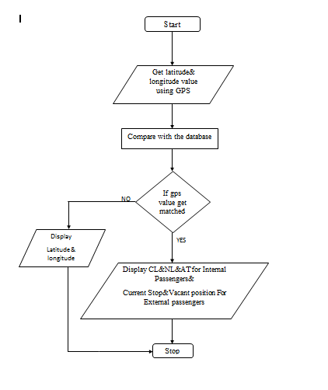

**LATTITUDE AND LONGTIDUE VALUE IN GPS :**

Collecting GPS data using mobile devices is essential to understanding human mobility. However , getting this type of data is tricky because of some specific features of mobile operating systems, the high- power consumption of, mobile device, and users privacy concerns . Therefore , data of this kind are rarely publicly available for scientific purposes, while private companies that own the data are often reluctant to share it . Here we present a large anonymous longitudinal database of Activity Point Location (APL) generated from mobile devices GPS tracking . The GPS data were collected by using the Google Location History (GLH) , accessible in the Google Maps application. GPS tracking points in Ecuador . Furthermore, we made our models publicly available to enable advanced anlayis of human mobility and activity spaces based on the collected .

CL&NL&AT for internal passing:

The CL systems that uses signal detectors and the refined characterstics of nonmotorized travel modes .It includes four modules : data acquisition module,data processing module , feature extraction module , and mode classification module.  
 The AT is the abbrivation is ARTIFICIAL TRANSPORT .It is the framework of addition to vehicles ,bicycles, pedestrians and other social environments.It explains the advantages cloud computing and GPUs and presents the architectures of the GPU-based cloud computing for the transportation systems.

VACANT POSITION FOR EXTERNAL PASSENGER:

The vacant point to other point factors , such as the need to decarbonize, which should also be consider. Algorithm should optimize the service mode in way that achieve the best outcomes or more fittingtly, the least impact . In the end, the network and movement of passenger will likely to assessed against the impact of an stakeholders and optimized for vacant position .

import random

import time

# Simulating IoT data collection from buses

class Bus:

def _init_(self, bus_id, route_id, current_location, speed):

self.bus_id = bus_id

self.route_id = route_id

self.current_location = current_location

self.speed = speed

def update_location(self):

# Simulating random movement

self.current_location += self.speed * random.uniform(0.8, 1.2)

def get_location(self):

return self.current_location

# Simulating data processing and optimization

class TransportOptimizer:

def _init_(self, buses):

self.buses = buses

def optimize(self):

for bus in self.buses:

bus.update_location()

def get_bus_locations(self):

return {bus.bus_id: bus.get_location() for bus in self.buses}

# Simulating the execution of the script

if _name_ == '_main_':

buses = [Bus(1, 'A', 0, 30), Bus(2, 'B', 10, 25)] # Simulated buses with initial parameters

optimizer = TransportOptimizer(buses)

for _ in range(5): # Simulating 5 iterations

optimizer.optimize()

print(optimizer.get_bus_locations())

time.sleep(2) # Simulating time delay between iteration

sPublic transportation optimization using IoT (Internet of Things) and web development simulations can greatly improve the efficiency, safety, and overall quality of public transportation systems. Here's an overview of how this can be achieved:

**1. Real-time Data Collection:**

- IoT sensors can be installed on buses, trains, trams, and at transportation hubs to collect real-time data. This data can include vehicle location, passenger counts, weather conditions, and traffic congestion.

**2. Data Processing and Analysis:**

- The collected data is sent to a central server for processing and analysis. Machine learning algorithms can be used to make predictions and optimize routes, schedules, and maintenance.

**3. Passenger Information and Communication:**

- Web development can be used to create mobile apps and websites that provide passengers with real-time information on vehicle locations, arrival times, and service updates.

**4. Traffic Management:**

- Traffic management systems can use IoT data to control traffic signals and improve the flow of public transportation vehicles, reducing delays and congestion.

**5. Energy Efficiency:**

- IoT sensors on vehicles can monitor fuel consumption and other energy-related metrics, helping transportation companies reduce their environmental impact and operational costs.

**6. Maintenance Alerts:**

- IoT sensors can monitor the condition of vehicles and infrastructure. When maintenance is required, alerts can be sent to the maintenance teams for timely intervention.

**7. Safety and Security:**

- IoT can enhance security through video surveillance and alert systems. Web applications can be used to monitor these systems and send alerts in case of security breaches or emergencies.

**8. Passengers Counting and Fare Collection:**

- IoT sensors can accurately count passengers boarding and disembarking, which can help optimize schedules and fare collection. Web apps can provide passengers with digital payment options.

**9. Simulation and Optimization:**

- Web-based simulations can model different scenarios for optimizing routes, schedules, and resource allocation. Machine learning models can continuously improve these optimizations based on real-time data.

**10. Integration with Smart Cities:**

- Public transportation IoT data can be integrated with other smart city initiatives, such as smart traffic lights, waste management, and energy management, to create a holistic urban environment.

**11. Accessibility and Inclusivity:**

- Web applications can be designed with accessibility in mind, ensuring that people with disabilities can easily access transportation information and services.

**12. Feedback Mechanisms:**

- Web applications can incorporate feedback mechanisms for passengers to report issues or provide suggestions, which can help transportation authorities improve their services.

**13. Data Visualization:**

- Web-based dashboards and mobile apps can display real-time and historical data in a user-friendly manner, allowing both passengers and transportation officials to make informed decisions.

Implementing such a system requires close collaboration between IoT experts, data scientists, software developers, transportation authorities, and city planners. It can lead to more efficient and user-friendly public transportation systems, reducing traffic congestion, lowering carbon emissions, and improving the overall quality of life in cities.

***Wireless sensors for vehicle data collection:***

PRS is a portable roadside sensor for vehicle detection, counting, classiﬁcation, and speed estimation [62]. PRS uses a magnetic sensor for vehicle detection. The single PCB board of PRS contains two magnetic sensors (HMC2003). This sensor uses the XBee module for wireless communication. PRS shows an accuracy of 99% in vehicle detection, and the maximum error rate of speed esti- mation is 2.5% (in a range of 5e27 m/s). Besides, the system also detects the right intersection. The vehicle length and height are estimated from the magnetic length.

LCTS is another low-speed congested trafﬁc sensor node with a magnetic sensor speciﬁcally for a single lane road [72]. The sensor node is designed using magnetic sensor HMC5883L. In addition to the magnetic sensor, the node also contains a sound sensor and four infrared sensors. However, the magnetic sensor alone performs vehicle detection and classiﬁcation. The validation results show a detection accuracy of 99.05% and a classiﬁcation accuracy of 93.66%.

The iVCCS is an intelligent vehicle counting and classiﬁcationsensor; the node has different sensors and components such as temperature sensor, accelerometer, magnetic sensor, GPS module, real-time clock unit, memory unit, etc. [8]. The iVCCS is a small battery-powered node with a 6-axis magnetic sensor and acceler- ometer FXOS8700. It uses a Zigbee wireless communication. The iVCCS nodes are validated in different ﬁeld trials and exhibit a 99.98% accuracy in vehicle detection, 97% accuracy in vehicle classiﬁcation, and 97.11% in speed estimation. The consistency of the sensor’s output under different conditions is tested and showed high similarity. Besides, the sensor node is portable and can be installed on the road as well as on roadsides.

CPIUS is the combined passive infrared and ultrasonic sensors

(CPIUS) for vehicle classiﬁcation and speed estimation [47]. The measurements from passive infrared sensors and ultrasonic sensors are used for vehicle classiﬁcation. They produce a high accuracy in vehicle detection (99%), the mean absolute error in speed estima- tion is approximately 5.87 km/h, and a mean absolute error of

0.73 m in vehicle length estimation. The proposed sensing platform contains one ultrasonic rangeﬁnder and two arrays of six passive infrared sensors (Melexis MLX90614) connected to a microcon- troller unit with different components such as an SD card reader, energy monitoring circuit, and ﬂash memory.

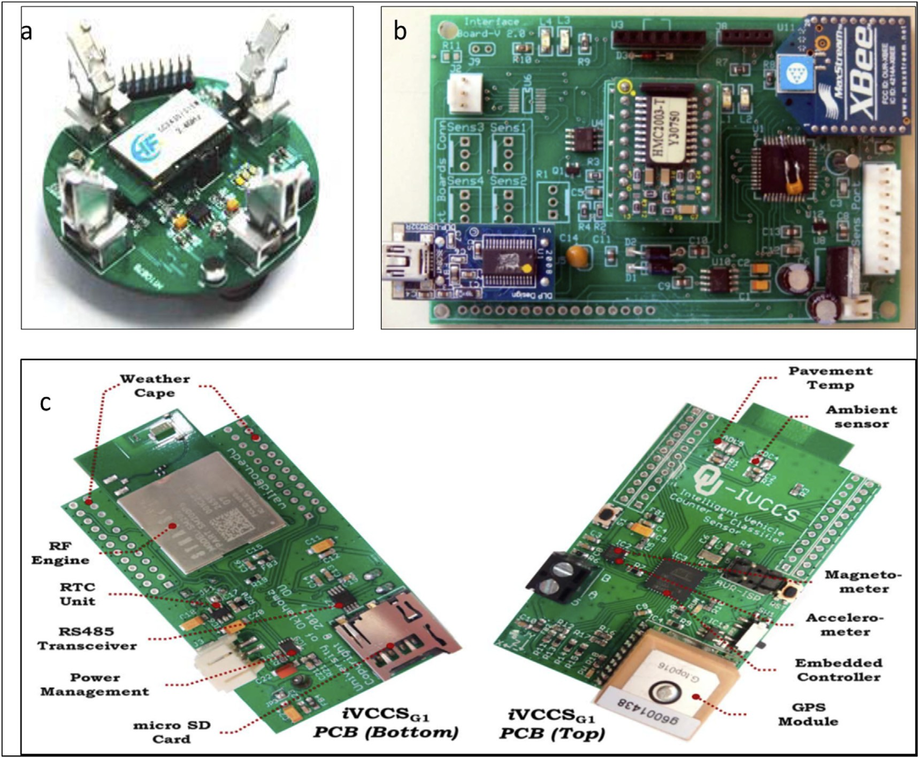

**The research methodology:**

The road occupancy measure is accurate for both highways and collector roads. Collector roads mostly have small vehicles, which has relatively low length hence a length based road occupancy measure is considered in this research. The road space occupancy measure is a spatial measure calculated by considering the length of the vehicle, the safe distance between vehicles, and a buffer length. The safe distance between the two vehicles is 2 m [2]. When a vehicle enters a road segment, the road occupancy measure is increased by the length of the vehicle and decreased when the vehicle exits from that particular road segment. Based on the literature review, this research has decided to go ahead with magnetic sensors (or magnetic sensor-based PCB) for collecting trafﬁc information as they show good accuracy in vehicle detection. The system design and development, demonstration, and evalua- tion phases are explained in upcoming sections.



**Evaluation:**

A step-by-step evaluation process has been executed to validate three main functionalities: (i) map processing and selection of message board location, (ii) vehicle data collection and processing, and (iii) dashboards.

***Selection of message board location:***

The map of the university is downloaded from the Open- StreetMap website. The OSM ﬁles are converted and loaded to MongoDB and the pictorial view is presented in figure. The original map is on the left and expected junctions are marked on the right.

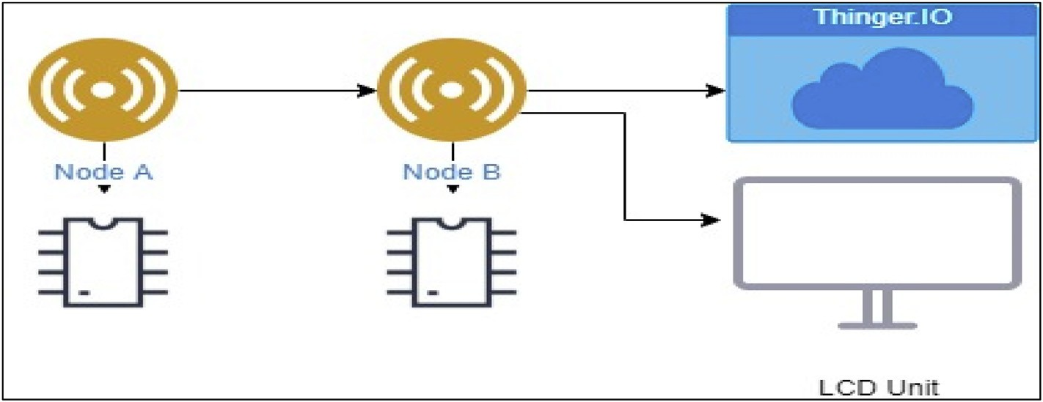

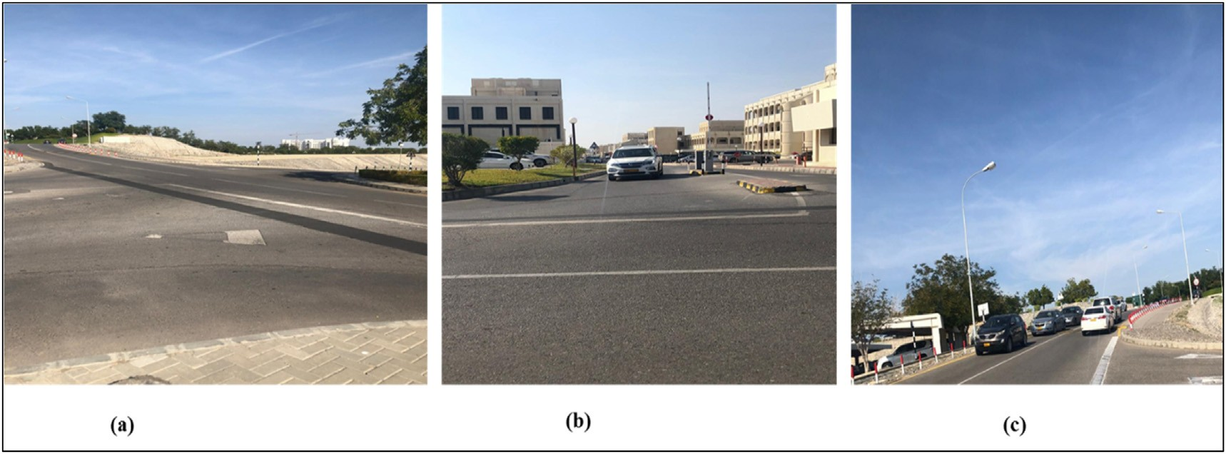

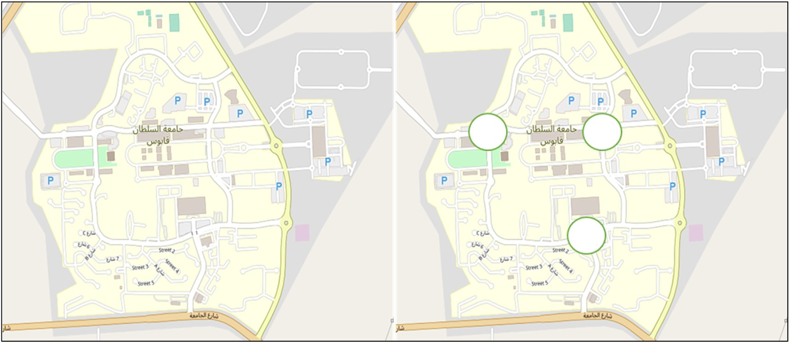

Precision % (Number of relevant junctions retrieved/Number of junctions retrieved) * 100%

¼

Recall % (Number of relevant junctions retrieved/Number of relevant junctions in the map) * 100%

¼